- For a doctor whose slots are no more available for that particular day, the system still allows booking an appointment for that. For example the below screenshot shows Dr. Mira Shaw available at 12.15PM slot for today (30-04-2026) – but I was trying to book at 7PM in the evening
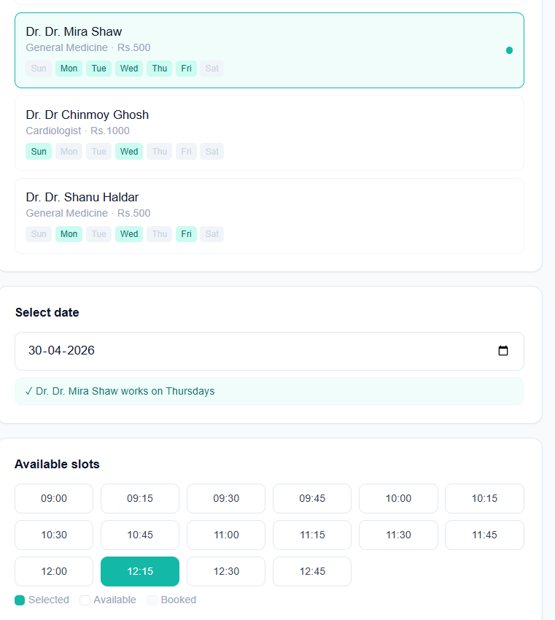

- Consumables are really not needed for OPD consultation. It would be more of use in Emergency, IPD and OT
- We need to add another role – Procurement – which will be responsible for keeping track of all the items including consumables and even pharmacy things when purchased. This will kind of be linked with the inventory module. Whenever a sale is made in the pharmacy for a particular medicine the inventory will get auto updated with the latest quantity left in stock whereas whenever a medicine is procured and added in the list by the procurement user role – the inventory gets auto updated with the additional quantity
- For adding doctors – even after adding the specialization – the error pops up – “Specialization needed” and does not allow to save the doctor
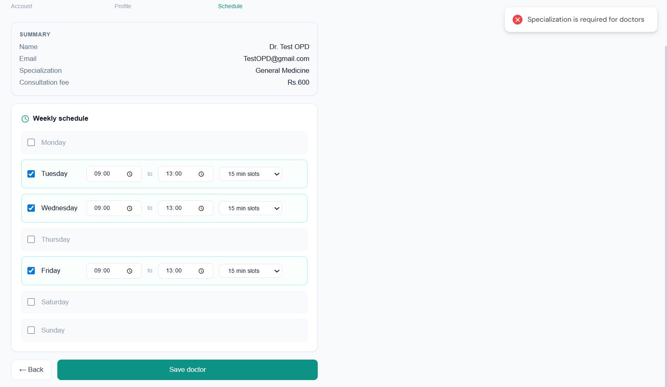

- There should be a mandatory option to mark the Doctor as “OPD”/”Emergency”/”IPD”/”Both”. In case the user selects – “both” option – for that particular doctor while selecting the schedule there should be an option to select the schedule for OPD and IPD individually. For Example - Dr. Mehta is available in OPD on Monday from 9am to 11am and in IPD on Tuesday from 2PM to 5PM. Also, on Wednesday - Dr. Mehta is available in OPD from 9am to 11am and in IPD from 2PM to 5PM. And similarly for emergency schedules as well
- “Book Appointment” screen does not show doctor’s available for OPD – All doctors are shown under “Emergency. User should be able to book appointment for a patient on any calendar date for a doctor basis the doctor’s availability and schedule on that date
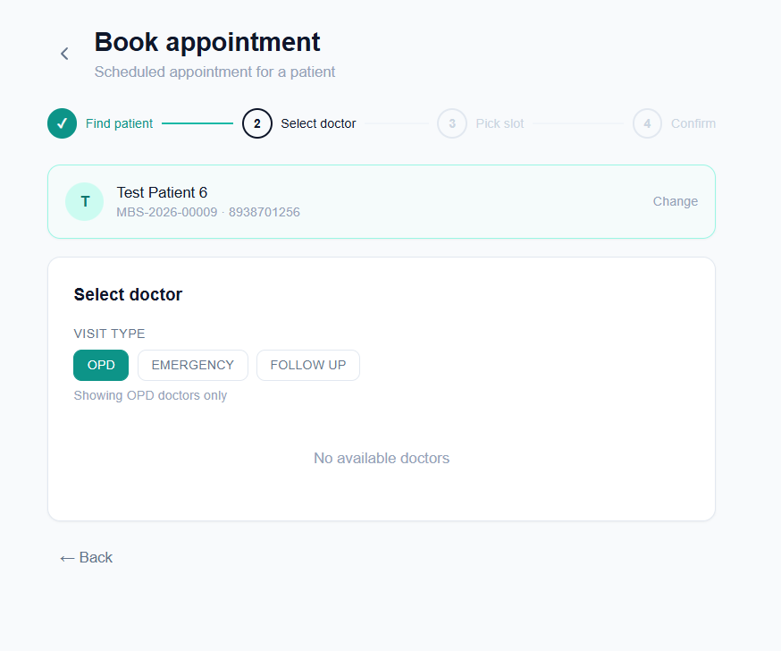
- Appointment with Dr. Mehta was booked on 4th May (today) at 9:30AM and Dr. Mehta was available till 1PM today. At 1:14PM the appointments page still has an option to “check-in” – which should not be there as the doctor’s scheduled time has already passed. Once a receptionist clicks on “End session” for any doctor – all the pending appointments for that doctor on that particular date should be marked as “No-Show”
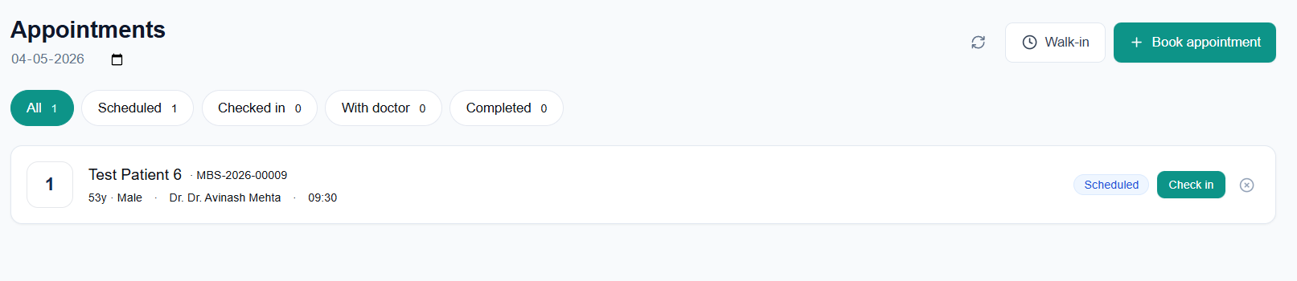

- The “With Doctor” button should be removed. Once the receptionist starts session for any doctor for the assigned OPD – the patient appointment with token 1 for that particular doctor automatically gets marked as “With Doctor”. When the doctor presses next and the token number in the display board moves to next, i.e., token 2, the patient appointment with token 2 for that particular doctor automatically gets marked as “With Doctor”.
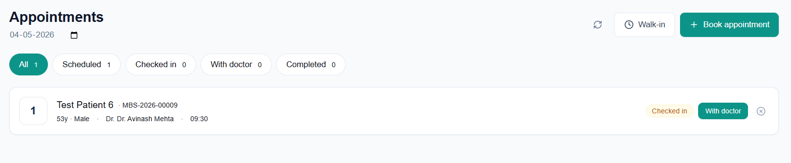
- If user clicks on book appointment from a patient profile – the patient details should get auto-filled. It currently happens if user clicks on “Walk-in” from the patient profile – but does not happen if user clicks on “Book Appointment”
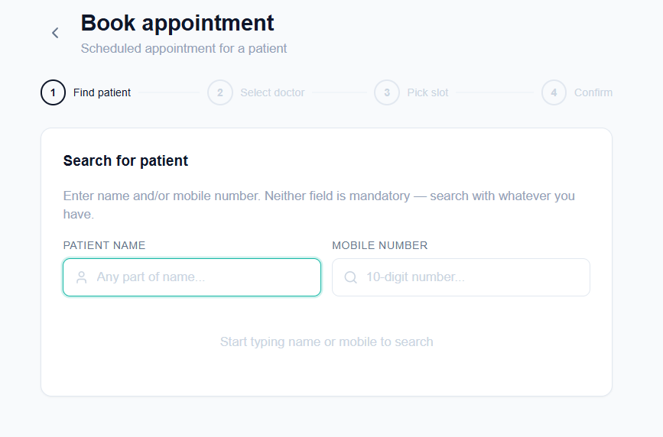
- Currently doctors are categorized into OPD/IPD/Both, but Doctor’s will be categorized as OPD/Emergency/IPD/Both. Only the OPD doctors to be made visible while making an OPD appointment and similarly for Emergency appointments and all others – based on the doctors availability on that particular day and similarly the IPD doctors to be shown only for IPD registrations
- For a single Doctor - his schedule for OPD and Emergency should be different as a single doctor cannot be present in OPD and Emergency at the same time. And the same is true for IPD as well. In other words a single doctor can be only at a single OPD/Emergency/IPD at a particular point of time. The scheduling should not allow same time and date schedules for a single doctor in more than 1 sector (OPD/Emergency/IPD)
- While booking an appointment – once the user selects a doctor – if the doctor is not available for the selected date - instead of showing “No slots available on 5th May 2026” – the system should show which date the doctor is available along with his time (example: Dr. … is available on Mondays (9am to 1PM) and Tuesdays (2PM to 5PM)
